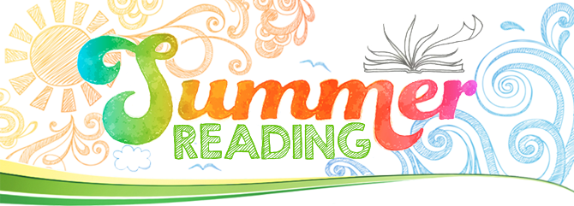

1. Finish reading and annotating *Rule of the Bone.*
2. Complete two entries per chapter for a total of 44 entries (yes, you can and should continue your current notes (you should have 18 already)—I am just broadening what you can gather quotes about).

Each entry can focus on any of the following literary devices:

* theme (conformity/non-conformity OR loss of innocence/coming of age)
* symbolism
* characterization

**Triple entry notes due to turnitin.com by August 17th by 11:59pm**. (see example and format below)

You can download the template on my website : amberstone.educatorpages.com

**You will get a new turnitin code when we begin classes in August.**

There will be a timed write and reading quiz on *Rule of the Bone* **the second full day of class**.

We will also have a discussion **August 16/17.**

DO NOT GET RID OF VOCAB NOTEBOOKS! WE WILL CONTINUE WITH THE VOCABULARY IN SENIOR YEAR!!



|  |  |  |
| --- | --- | --- |
| **Literary Device** | **Quote/Evidence** | **Analysis/Reasoning** |
| * **Theme** * **Symbolism** * **Characterization** | **Be sure to cite your evidence with a page number.** | **You need at least 2 sentences of reasoning per quote.** |
| **Theme:**  **Non-Conformity** | **Chappie says,** “I was already driving her and Ken crazy with my lousy grades in school and… getting a Mohawk haircut and nose rings and being a general pain in the royal ass…” **(7).** | **This reveals** that Chappie does not follow the norms that his parents expect him to adhere to.  **This suggests** that he is attempting to rebel against his parents and does not feel the need to conform to society. |

If you want me to get *Rule of the Bone*

for you it is $13 by Friday, 6/1.

Or, check it out from the library.

You can also get a Kindle version for about $10.

